Arduino Step-by-step tutorial

# Setup development environment

## Install Arduino IDE

Go to <https://www.arduino.cc/en/main/software> to download Arduino IDE and install it to your computer.

The open-source Arduino Software (IDE) makes it easy to write code and upload it to the board. It runs on Windows, Mac OS X, and Linux.

## Install necessary library

We need library for RF24 and MPU6050 to program for RF transceiver and Gyro sensor. While RF24 library can be downloaded from Online Arduino library, the MPU6050 needs to be installed using feature “Add .ZIP library” from Arduino. Please follow the steps below to install both of them.

Step 1: Open Arduino IDE

Step 2: Install RF24 library

Open Arduino Library Manager. The library manager is located in Sketch menu or Tools menu depending on your Arduino IDE version.

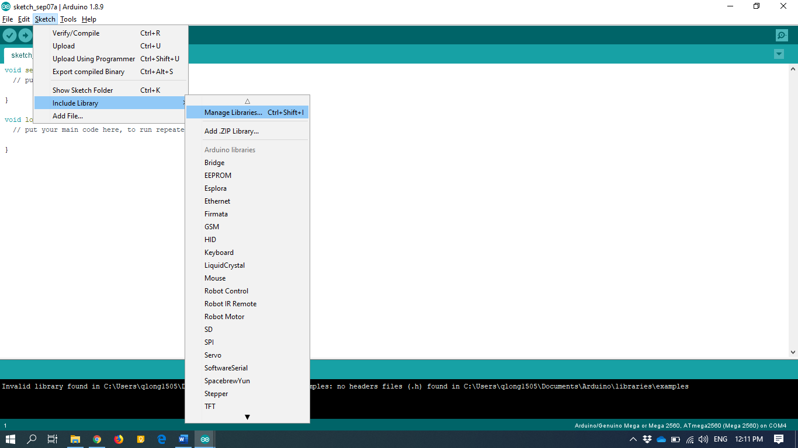

Search for RF24 and click install. **NOTE**: There are many sources of library. In the workshop, we will use “RF24” library.

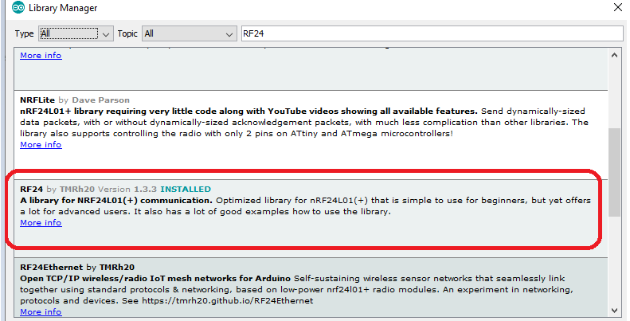

Step 3: Install MPU Library from Zip file.

**Firstly, download MPU library Zip file at this link**

<https://www.dropbox.com/s/e3skmfwape7vs6z/MPU6050.zip?dl=1>

**Next, from Arduino IDE, choose Sketch🡪Include Library🡪 Add .ZIP library…**

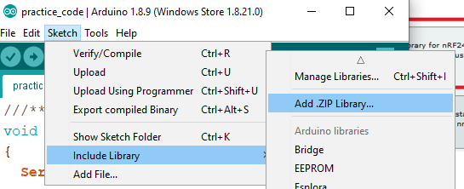

Then navigate to your downloaded zip file location and choose open

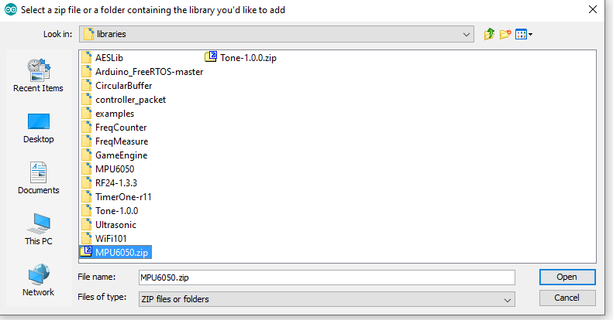

Well done! You have finished steps to install the necessary library for the workshop.

## Hardware board configuration

### Choose Arduino Uno board

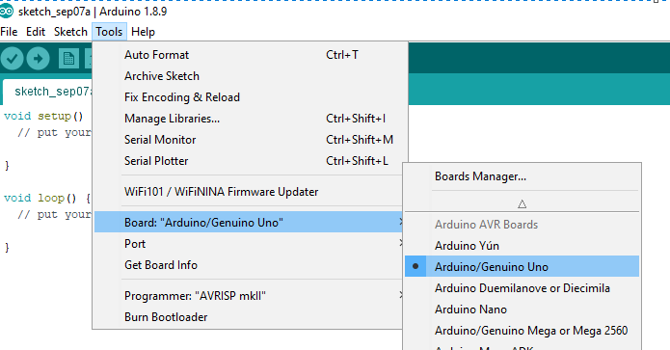

### Select Port of the Arduino hardware

Step 1: DO NOT plug Arduino board to your PC, then go to the port to check current system’s ports

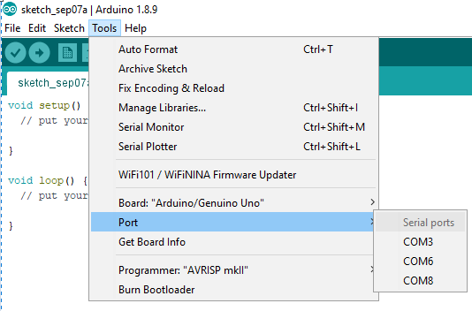

Step 2: Plug the Arduino Board to your PC, then check the port again, a new COM port should show up and select this port

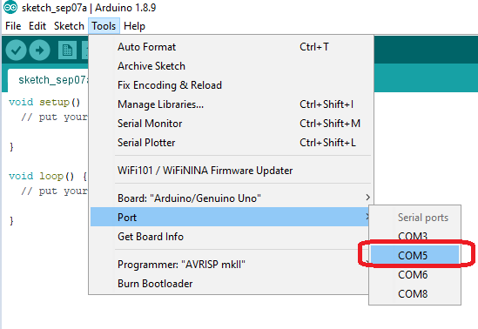

# Test example code

Follow the picture instruction to open the example library and try to run on Arduino.

**Try to understand the code?** No worry, give the friendly voluntary helpers a yell in the workshop to get help!

## Test Button program

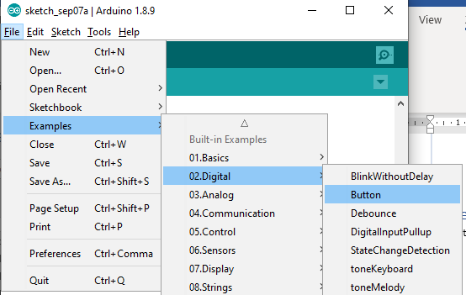

## Gyro MPU6050 sensor

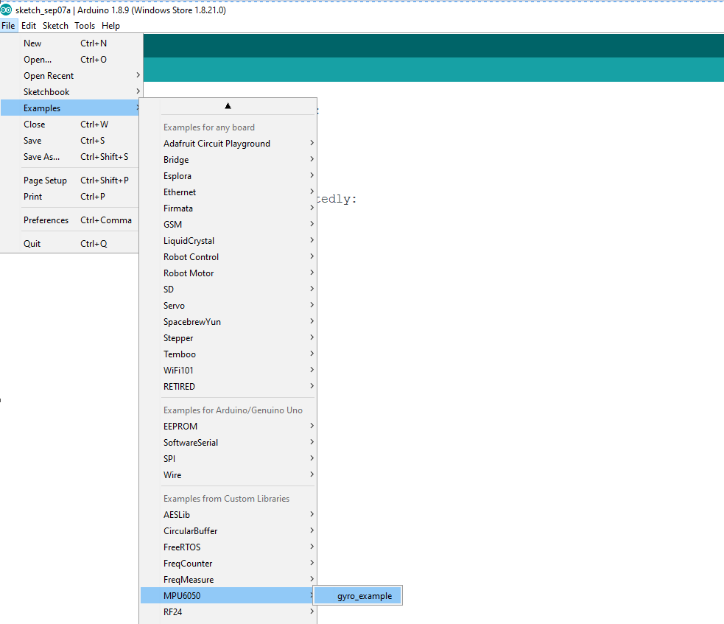

## RF24 transceiver

Now let’s start to run the example code from RF24 library. Please follow the instruction in the below photo

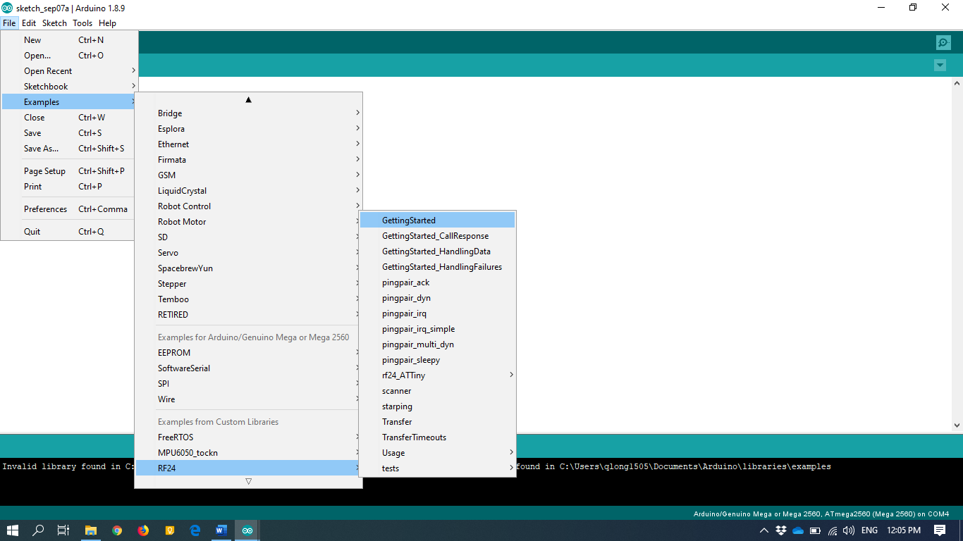

**Need help?** No worry, give the friendly voluntary helpers a yell in the workshop to get help!

**Note 1: We use pin 5 & 10 in the workshop so change radio(7,8) to radio(5,10) at line 16**

/* Hardware configuration: Set up nRF24L01 radio on SPI bus plus pins 7 & 8 */

RF24 radio(5,10);

**Note 2:** We need two boards to test the transmission. One board can be the receiver and the other one can be the transmitter. At line number #13, value of the ***radioNumber*** can be set to 0 or 1. If the first board is set to 1, you **MUST** change to 0 before upload to the second board. Missing this step will make two boards be impossible to communicate together.

/****************** User Config ***************************/

/*** Set this radio as radio number 0 or 1 ***/

bool radioNumber = 1;

# Time to practice:

**Problem to solve:** Send gyro’s X and Y data from one Arduino board to another Arduino via RF24 module.

